Certificate of Analysis

General properties:
Name： MAL-PEG2000-COOH
Molecular Weight： 2000 Dalton
Cat.#：R-1080
Lot.#：1554151
Manufacture Date： 2015.09.21
Date of Analysis： 2015.09.21
Recommended Retest date： 2016.09.21
Stability： 12 months
Storage： -20°C in the dark

Structure

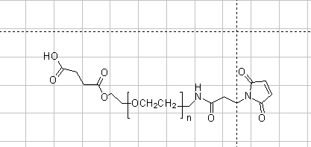

Items | Specification | Results
Appearance | Off-white / Light yellow solid | Light yellow solid
¹H NMR | Identical to the Structure | Identical to the Structure
Foreign Material | None | None
Purity | ＞90% | 90%
Report Date: 2015.09.21

This product is for research use only, Not for human or animal use

